**IFT 466 Advanced Computer Networks**

**Lab 9  
EIGRP – Encrypted Authentication**

After you complete each step, put a ‘√’ or ‘x’ in the completed box

**Objective**You can prevent a router from receiving fraudulent route updates by configuring router authentication.   
  
You can configure EIGRP neighbor authentication such that routers can participate in routing based on predefined passwords.

By default, no authentication is used for EIGRP packets. You can configure EIGRP to use MD5 authentication.

This lab will show you how to configure routers so to authenticate EIGRP packets over an interface.

1. Setup the following topology in Packet Tracer

****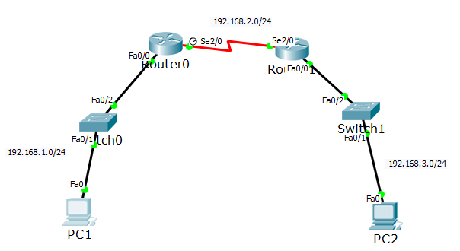

✓

1. Configure the PCs and Routers with the IP configurations as shown in the topology



✓

1. Enable the EIGRP routing process on each router using AS number 1

Advertise directly connected networks via the network command

✓

1. Verify EIGRP Routing

Use the show ip route to see that the routers have learned the other subnets



✓

1. Verify end-to-end connectivity. PC1 and PC2 should now be able to ping each other.

If not, troubleshoot your EIGRP configurations.



✓

1. We will now configure authentication on R1.

Configure a key chain on R1 called wan-auth (this name does not need to match R2 as it is only locally significant or choose any other name you wish)

We then add Key and give it an identifier i.e. 1 so now Key 1  
  
**Note:**It is recommended that the key number be the same on all routers involved in the configuration.

Routing authentication relies on a key on a keychain to function. Before authentication can be enabled, a keychain and at least one key must be created.  
  
We then need to specify the key-string for the key

We then enter a password Cisco on the key-string

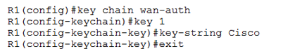



✓

1. We will now enable this authentication by going to the interface to Serial 2/0 and enable the authentication on R1.

The 1 used here is the autonomous system number of the network. MD5 indicates that the md5 hash is to be used for authentication

The neighbor will go down as it cannot authenticate with EIGRP, so we will not receive any packet from this neighbor any more





✓

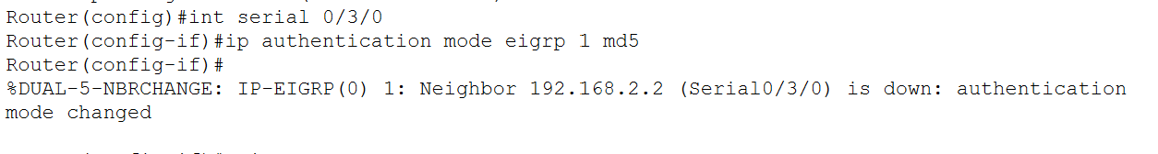

1. The next line specifies the keychain that should be used for authentication i.e.wan-auth. The command tells EIGRP where to get the password, telling it to use the key-chain name wan-auth to get the password Cisco

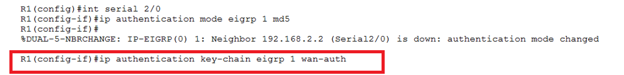



✓

1. Run the show ip eigrp neighbors command on R1 and it should be blank as we have no neighbors right now as we cannot authenticate with R2



✓

1. Repeat the same authentication on R2 (with the same password ‘Cisco’) so we can create the neighbor relationship again.

You will eventually get the following message that we now have a neighbor relationship as we were able to authenticate using key chain wan-auth (could be a different value on each router) which has a password Cisco (needs to be the same on both routers)



 ✓

1. Now re run the show ip eigrp neighbors command on R1 and you will now see the neighbor

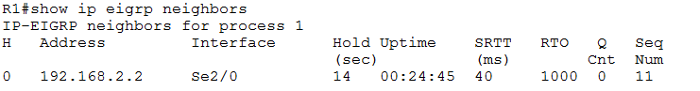

 ✓

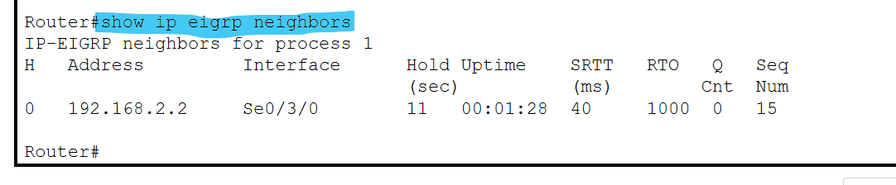

1. Now run the show run command to see the configuration on the serial interface

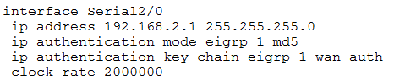

 ✓

1. Once EIGRP message authentication is configured on all three routers, they begin to exchange EIGRP messages again. This can be verified by issuing a debug eigrp packets command.

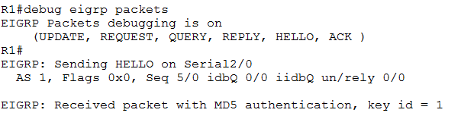

Packets from R2 with MD5 authentication are received.

 ✓

1. Now do another ping from PC1 to PC2.   
     
   Was it successful, if not troubleshot to find out why?



✓

